**PHASE-2: INNOVATION**

**TOPIC: PUBLIC TRANSPORTATION OPTIMIZATION.**

**IBM : NAAN MUDHALVAN: IOT-GROUP 4**

**ZONE-14**

**MENTOR: K.Priyanka M.E.., Assistant Professor.**

**TEAM MEMBER**

**912621104018 : M.PRIYA**

INTRODUCTION:

The IOT is an important carrier for collecting, transmitting, processing, and applying information. Related technologies such as big data, cloud computing, sensors, and so on are widely used in various fields, especially the logistics industry. The continuous improvement of the urban system makes the establishment of a good urban distribution system, a problem that must be solved to increase the development of the urban economic system. The optimization of the transportation path of the distribution vehicle is a vital link in the urban logistics distribution system, which connects the production line, warehouses, and consumer.

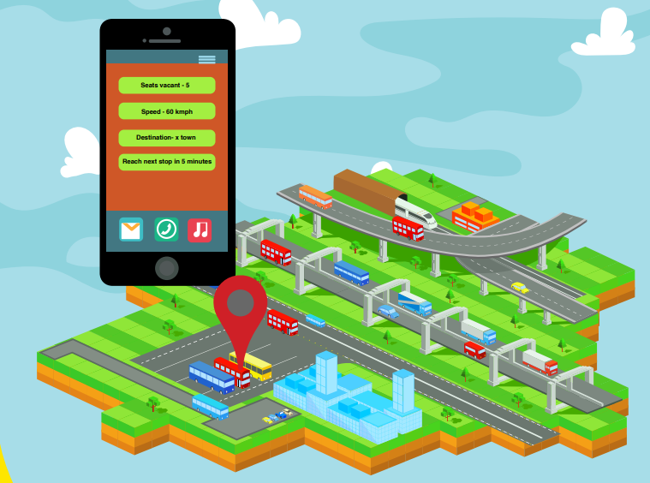

Intelligent Road Transport System Scenario - A Detailed Analysis

Public transportation is reducing energy consumption and harmful carbon dioxide (CO2) greenhouse gas emissions that damages the environment. Traveling by public transportation uses less energy and produces less pollution as compared to travel in private vehicles. To make progress in reducing our dependence on foreign oil and impacting climate change, public transportation must be part of our M2M solution. State Transport system in India is inefficient and slack. Lots of buses are involved in the public transport; they run on the scheduled time every day. The system has many problems that could be resolved by implementing M2M solutions.

Note:

The Use Case is prepared by considering the Indian scenario rather than referring other countries’ systems. Some of the recommendations would be for green field and some of them could be adopted by the existing system.

Objectives:

• To develop a Smart system that could benefit RTC (Road Transport Corporation) as well as the passengers

• To develop a business model where operator can act as an Enterprise Service Provider

• To encourage the passenger to use public transport for commuting there by reducing traffic congestion, air pollution etc.

Requirements:

• GPS devices • Wheel speed sensors • Torque sensors • Sensors measuring the health of the vehicle

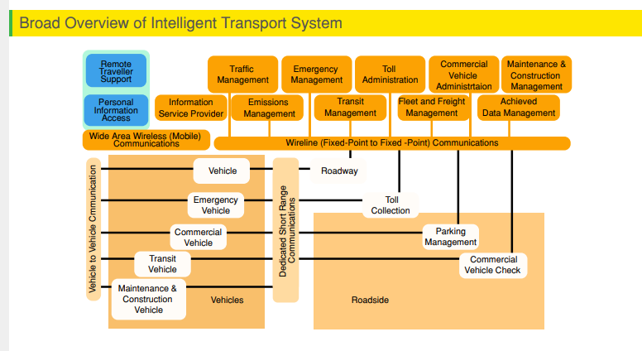

Planning and managing the buses:

The basic requirements for the use case is that all the Bus depot are connected to each other and all the small bus stands will be connected to the respective depots of the town. The source depot will update the departure time of the bus to all the bus stands and the destination depot. GPS tracking and tracing systems will provide the information about how far the bus is from the destination and the estimated time of arrival. The number of the passengers waiting at the respective bus stand will be updated frequently

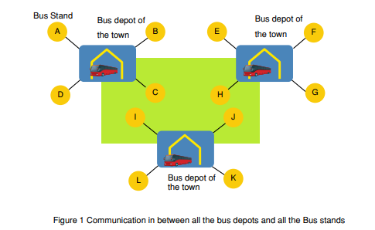

Here, one scenario is discussed where at different times buses will depart from the depot X for the destination depot Y. The route will cover all the bus stops in between and bus timings are already predefined.

• Bus will depart from X depot with 50 vacant seats.

• It will pick up 30 passengers from 1st bus stop then the dashboard at the bus stop will display the information as shown in the below diagram.

• After filling up the seats at the 2nd bus stop the bus will communicate with the bus depot X and also with all the bus stop regarding no vacant seats.

•. Bus depot will make the arrangement of another bus and it will send the notification to all the bus stop about the departure and arrival time of the bus.

• At the same time bus will be notified about the passengers waiting at the 3rd and 4th bus stop.

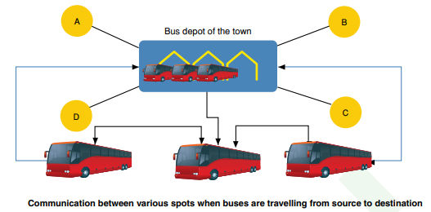

Here are some IoT innovation ideas for optimizing public transport:

**Smart Ticketing Systems**: Implement IoT sensors in public transport vehicles and stations to enable contactless ticketing and fare collection. Passengers can use their smart phones or smartcards for seamless payment.

**Predictive Maintenance:** Equip public transport vehicles with IoT sensors to monitor their condition in real-time. This data can be used to predict maintenance needs, reducing breakdowns and improving service reliability.

**Real-time Passenger Information**: Install IoT displays at bus stops and train stations to provide real-time updates on vehicle arrival times, delays, and route changes, helping passengers plan their journeys more efficiently.

**Traffic and Congestion Monitoring**: Use IoT devices and cameras to monitor traffic conditions and congestion on routes. This data can be analyzed to optimize route planning and reduce delays.

**Vehicle Tracking and Fleet Management**: Employ IoT-enabled GPS tracking to monitor the location of public transport vehicles, ensuring efficient deployment and better coordination during peak hours.

**Energy Efficiency:** Implement IoT sensors to monitor and control the energy consumption of public transport vehicles, reducing environmental impact and operational costs.

**Safety and Security**: Install IoT-based surveillance systems inside vehicles and at stations to enhance passenger safety and deter criminal activities.

**Smart Bus Stops and Shelters**: Create smart bus stops and shelters equipped with IoT sensors, offering Wi-Fi connectivity, weather updates, and charging stations for passengers.

**Demand-Responsive Services:** Develop IoT-powered algorithms that adapt public transport routes and schedules based on real-time demand data, optimizing resources and reducing empty trips.

**Passenger Feedback Systems:** Collect feedback from passengers through IoT-enabled kiosks or mobile apps to continuously improve public transport services based on user input.

**Noise and Pollution Monitoring:** Use IoT sensors to measure noise levels and air quality around public transport routes, enabling authorities to take measures to reduce pollution and noise pollution.

**Accessibility Enhancements:** Implement IoT solutions to assist passengers with disabilities, such as automatic ramps and doors, audible announcements, and real-time accessibility information.

These IoT innovations can help enhance the efficiency, safety, and convenience of public transport systems while reducing their environmental impact.

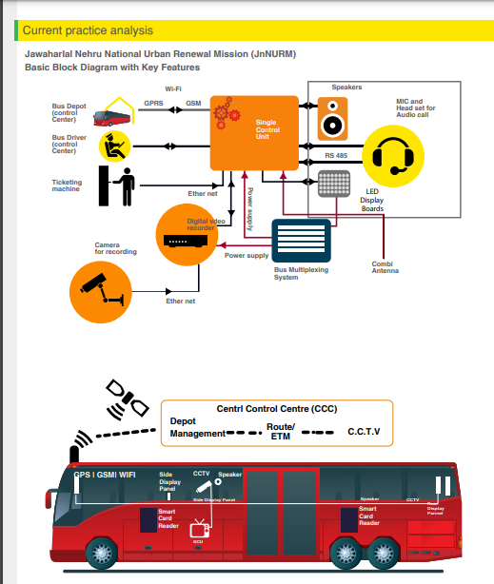

**Incorporating machine learning algorithms to improve arrival time prediction accuracy based on historical data and traffic conditions is a great idea. Here are the key steps you can follow to implement such a system:**

**Data Collection:** Gather historical data on routes, including timestamps of past journeys, traffic conditions, weather, and any other relevant information that may affect travel times.

**Data Preprocessing:** Clean and preprocess the data to handle missing values, outliers, and inconsistencies. Feature engineering can also be essential to extract relevant information from the raw data.

**Model Selection:** Choose machine learning algorithms suitable for time series data and regression tasks. Common choices include Linear Regression, Random Forest, Gradient Boosting, and more advanced models like Long Short-Term Memory (LSTM) networks for deep learning.

**Feature Selection:** Identify the most important features that impact arrival times and use them as inputs to your model. Feature selection techniques like feature importance scores or recursive feature elimination can help.

**Model Training:** Split the data into training and testing sets to evaluate model performance. Train your chosen algorithm on the training data and fine-tune hyper parameters to optimize performance.

**Validation and Testing:** Evaluate the model's accuracy and performance using the testing dataset. You can use metrics like Mean Absolute Error (MAE) or Root Mean Squared Error (RMSE) to measure prediction accuracy.

**Real-time Data Integration**: Incorporate real-time data sources, such as traffic updates, into your model for more accurate predictions. APIs from services like Google Maps or Waze can be valuable for this purpose.

**Deployment:** Once satisfied with the model's performance, deploy it as a service or integrate it into your navigation app. Ensure it can handle continuous updates and adapt to changing traffic conditions.

**Continuous Learning:** Implement mechanisms for model retraining and updates to account for changing traffic patterns and new data. This ensures your predictions remain accurate over time.

**User Feedback:** Collect user feedback to further improve your model and incorporate user suggestions or corrections into the prediction system.

By following these steps and continuously refining your machine learning model, you can significantly improve arrival time predictions for your navigation or transportation application.

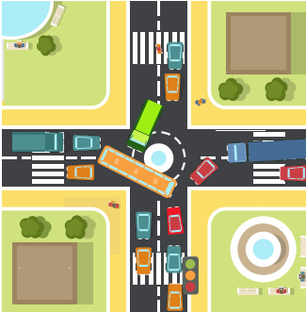

.

**Optimizing public transport using IoT (Internet of Things) innovations involves collecting real-time data from buses, trains, and other transportation modes to improve efficiency, safety, and passenger experience. Here are some ideas and coding concepts to get you started:**

**Real-time Tracking and Monitoring:**

* Use GPS and sensors to track the location and speed of vehicles.
* Collect data on fuel consumption, engine health, and maintenance needs .Code a dashboard or mobile app to display this data for operators and passengers.

**Predictive Maintenance:**

* Implement predictive maintenance algorithms to detect and prevent breakdowns.
* Use machine learning to analyze sensor data and predict when maintenance is required.
* Create alerts and maintenance schedules based on the predictive analysis.

**Smart Traffic Management:**

* Develop algorithms to optimize traffic signals based on real-time traffic flow.
* Use IoT to coordinate traffic lights to reduce congestion and improve bus scheduling.

**Passenger Information Systems:**

* Build mobile apps or digital signage for real-time bus and train arrival information.
* Use IoT data to estimate arrival times accurately.
* Provide updates on delays or route changes to passengers.

**Ticketing and Payments:**

* Implement contactless payment systems using IoT-enabled cards or smart phones.
* Create secure, encrypted protocols for processing payments.
* Develop apps for passengers to purchase tickets and check their balances.

**Environmental Monitoring:**

* Deploy IoT sensors to measure air quality and noise pollution.
* Code systems to display this data to passengers and transportation authorities.
* Use data to optimize routes to minimize environmental impact.

**Security and Safety:**

* Install surveillance cameras in vehicles and stations for security.
* Develop facial recognition or object detection algorithms for identifying potential threats.
* Code emergency notification systems for passengers and authorities.

**Energy Efficiency:**

* Use IoT to monitor and optimize energy consumption in vehicles and stations.
* Implement smart lighting and HVAC systems that adjust based on occupancy.
* Develop algorithms to minimize energy waste.

**Fleet Management:**

* Build a fleet management system to track vehicle availability, maintenance, and scheduling.
* Optimize routes and resource allocation using data-driven insights.
* Automate vehicle assignments and maintenance requests.

**Data Analytics and Reporting:**

* Develop data analytics pipelines to process and analyze IoT data.
* Create reports and visualizations to identify trends and make data-driven decisions.
* Implement machine learning models for demand forecasting and route optimization.
* Remember to prioritize data security and privacy, as IoT systems often involve sensitive information. Additionally, consider scalability and reliability in your coding efforts to ensure the long-term success of your public transport optimization project.

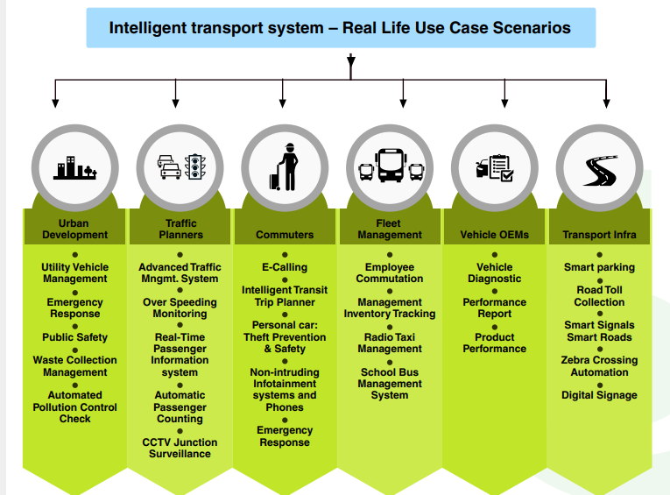

**Conclusion:**

The integration of IOT technology into smart public transportation has the potential to revolutionize the way public transportation is managed, optimizing transportation routes, improving the overall passenger experience, and reducing emissions. As IOT technology continues to evolve, we can expect to see even more innovative applications means public transportation, further enhancing the efficiency and effe0ctiveness of public transportation system.